American International University-Bangladesh (AIUB)  
**Department of Computer Science  
Faculty of Science &Technology (FST)  
Summer 24-25**

**< Reliable and safe route-finding system: A risk-free approach >**

Software Requirement Engineering

Sec: **B**

Project submitted

By

*MD. RABIUL ISLAM ASIF (22-48011-2)*

*JOY SARKER (22-49903-3)*

*Yasir,Samin (18-39121-3)*

*Akter, Khadiza (21-45651-3)*

**Checked By Industry Personnel (Optional)**

Name:

Designation:

Company:

Sign:

Date:

**1. ROBLEM DOMAIN**

**1.1 Background to the Problem**

Safety while travelling daily such as whether walking, using public transport, or travelling by private vehicles has become a real concern in cities like Dhaka. Incidents like pickpocketing, robbery, harassment and road accidents happen often, especially in places with poor lighting, unregulated traffic and limited security on empty roads.

One of the major reasons is the lack of easy access to real-time safety informationfor everyday people. Pedestrians, delivery workers, tourists and drivers often do not know which areas are currently unsafe. Although Government agencies gather some data, this information is rarely shared with the public in a timely or user-friendly manner which cannot be used effectively or maybe the system is not yet robust yet, or it may not even be priority.

**Root Causes of the Problem**

i. Limited access to reliable, real-time data about safety risks.  
ii. No centralized, community-driven reporting system.  
iii. Delayed responses due to low public awareness and late reporting.  
iv. Unregulated traffic and unsafe road conditions make travel riskier.

As a result, both locals and visitors must make travel choices without clear information, increasing the risk of experiencing crime or unsafe situations.

**1.2 Solution to the Problem**

The goal of this project is to develop a **Reliable and Safe Route-Finding System** that uses community input, user reports, and mobile app technology to offer safer travel options.

Instead of depending on government CCTV or police databases, this system will focus on privately sourced data such as:

* **User Reports**: Citizens can quickly report incidents like theft, harassment, traffic jams and unsafe areas.
* **Feedback & Ratings**: Users can rate locations, bus stops and routes based on their safety experiences.
* **Community Verification**: A system to confirm reports through upvotes, comments and repeated confirmations.
* **Integrated Navigation**: The app can recommend safer routes using safety ratings and incident data, along with standard GPS navigation.

**2. SOLUTION DESCRIPTION**

* **System Features**

**Feature 1: User Authentication & Profile Management**

* **Functional Requirements:**
  + Users can sign up, log in, and reset their password.
  + Profile management includes updating personal information and emergency contacts.
  + The system validates credentials before granting access.
* **Quality Attributes:**
  + **Security:** Password encryption and secure login with OTP/two-factor authentication.
  + **Usability:** Simple registration and recovery process for all users.

**Feature 2: Real-Time Incident Reporting & Alerts**

* **Functional Requirements:**
  + Users can report incidents (e.g., theft, harassment, unsafe road, accidents).
  + Reports can include text, images or location tags.
  + The system automatically timestamps and geo-tags reports.
  + Users receive alerts about incidents in their vicinity.
* **Quality Attributes:**
  + **Reliability:** Alerts and reports are delivered in real time.
  + **Performance:** Report submission and alert delivery within 2-5 seconds, even under low connectivity.

**Feature 3: Community Report Validation (Volunteers)**

* **Functional Requirements:**
  + Volunteers can validate reports submitted by users.
  + Volunteers can confirm, dismiss, or categorize reports (e.g., traffic, crime and hazard).
  + Volunteers can mark suspicious or duplicate reports.
* **Quality Attributes:**
  + **Accuracy:** Validated reports prioritized in safety calculations.
  + **Trustworthiness:** A reputation-based system to ensure credibility of validators.

**Feature 4: Feedback & Safety Ratings**

* **Functional Requirements:**
  + Users can provide feedback on routes, incidents, and locations.
  + Volunteers and admins can review and edit feedback for quality.
  + Safety ratings (1-5 stars or emoji-based) are integrated into route safety scores.
* **Quality Attributes:**
  + **Scalability:** Capable of processing thousands of feedback entries daily.
  + **Usability:** Lightweight rating interface for quick input.

**Feature 5: Safe Route Navigation**

* **Functional Requirements:**
  + Users can search for routes and track their progression.
  + The system suggests alternative routes with safety scores.
  + Routes dynamically update based on live incident reports.
* **Quality Attributes:**
  + **Efficiency:** Route calculations completed in under 5 seconds.
  + **Availability:** Cached maps enable offline functionality.

**Feature 6: Notifications & Live Crime Alerts**

* **Functional Requirements:**
  + The system sends real-time notifications when users approach unsafe areas.
  + Users receive push notifications even when the app runs in background mode.
  + Admins and volunteers can send priority alerts in emergency situations.
* **Quality Attributes:**
  + **Responsiveness:** Notifications delivered within 2-5 seconds.
  + **Reliability:** Works consistently across mobile devices and network conditions.

**Feature 7: User Progression & Reputation System**

* **Functional Requirements:**
  + Users earn **progression points** for submitting authentic and verified reports.
  + Points increase user reputation, unlocking higher trust levels.
  + False or misleading reports reduce progression points.
  + High-reputation users may receive special privileges (priority alerts, trusted reporter badge).
* **Quality Attributes:**
  + **Trustworthiness:** Encourages honest reporting and discourages false alerts.
  + **Engagement:** Motivates users to contribute actively through gamification.

**Feature 8: Crime Data Analysis & Admin Dashboard**

* **Functional Requirements:**
  + The system analyzes crime data to detect patterns and progression.
  + Admins can view heatmaps of unsafe areas and track reports.
  + Reports can be generated daily/weekly for decision-making.
* **Quality Attributes:**
  + **Security:** Access restricted to authorized administrators.
  + **Maintainability:** Dashboard can be easily updated with new metrics and analytics.

**2. UML Diagrams**

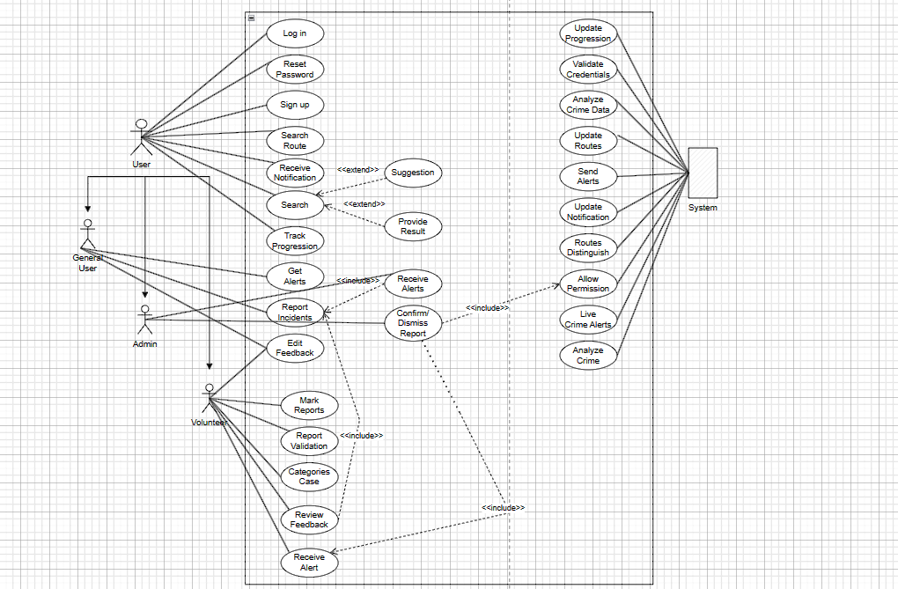

**Fig-1: Use Case Diagram**

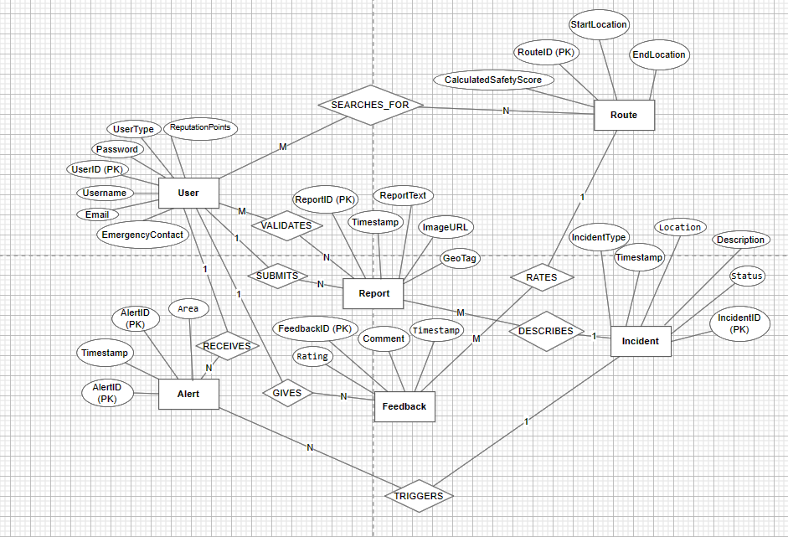

**Fig-2: E-R Diagram**

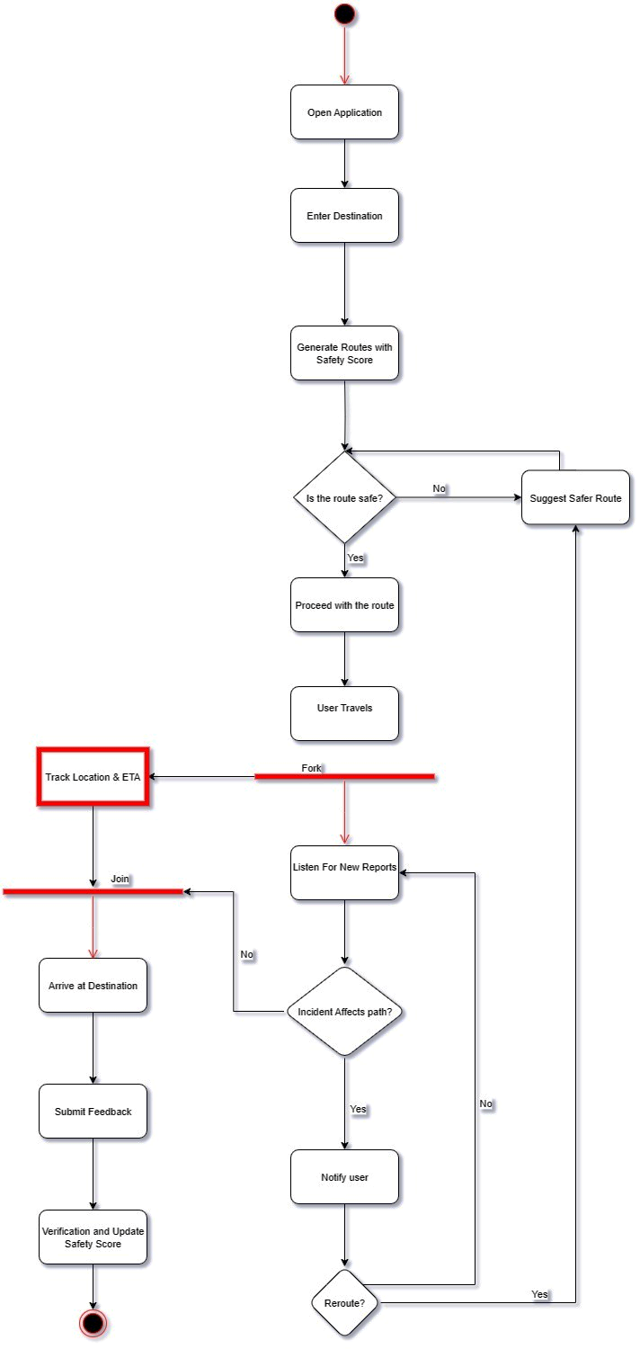

**Fig-3: Activity Diagram**

**3. Social Impact**

The proposed Reliable and Safe Route-Finding System aims to bring significant positive impact to society by addressing one of the most pressing challenges in urban life **safety during travel**. In densely populated cities like Dhaka, where incidents of pickpocketing, robbery, harassment and unsafe traffic conditions are frequent, individuals often lack access to real-time safety information. By introducing a community-driven, technology-based solution, this project has the potential to improve quality of life and enhance public trust in technology for social welfare.

### **Safer Daily Travel**

The application empowers individuals such as office workers, students, delivery personnel and tourists to make informed decisions about their travel routes. By avoiding unsafe areas and receiving alerts about nearby incidents, users can reduce the risk of being exposed to crime or accidents.

### **Community Awareness and Participation**

The system is designed to encourage **community engagement**. Citizens can contribute by reporting incidents, validating information and rating locations based on safety. This collaborative approach builds a culture of responsibility, where individuals are motivated to look out for each other, ultimately fostering a stronger sense of community.

### **Support for Law Enforcement and Policy Makers**

Although the system primarily relies on community reports, aggregated data and analytics can be shared with local authorities. Features such as crime heat maps and safety trend reports can help policy makers and law enforcement agencies identify high-risk zones, allocate resources effectively and design long-term safety improvement strategies.

### **Improved Public Confidence**

When people feel safer while traveling, overall confidence in urban mobility increases. This not only benefits individuals but also contributes to the economy by encouraging greater participation in public activities, commerce and tourism. Safe transportation routes are particularly valuable for vulnerable groups such as women, children and elderly citizens.

### **Technological Literacy and Innovation**

The use of mobile applications for community-driven safety reporting promotes **digital literacy** and showcases how technology can be harnessed to solve real-world social problems. By engaging citizens in the reporting and verification process, the project also introduces them to the principles of transparency, accountability and shared responsibility.

**4. Development Plan with Project Schedule**

The development of the Reliable and Safe Route-Finding System has been structured according to the **Software Development Life Cycle (SDLC)** to ensure a systematic and organized approach. Each phase of SDLC has been carefully planned and scheduled using a **project management tool (ClickUp)**, where a detailed Gantt chart outlines tasks, dependencies, and deadlines. The entire project spans approximately **six months (February 2026 – July 2026),** beginning with requirement gathering and ending with deployment and handover.

This structured plan allows the team to maintain clarity, assign responsibilities effectively and track progress at every stage. The phases are described below:

### **Planning Phase (Feb 5 – Feb 28, 2026)**

The planning stage is crucial as it establishes the foundation of the project. During this period the team focuses on:

* **Gathering requirements and user stories** through surveys and discussions to capture the needs of travelers regarding safety.
* **Researching existing applications** and safety-route technologies to identify gaps and best practices that can be adopted.
* **Defining the MVP (Minimum Viable Product) scope**, which prioritizes essential features such as user authentication, incident reporting and safe routing.
* **Assigning roles and responsibilities** among team members to ensure accountability and a balanced workload.

This phase ensures the team has a clear vision and roadmap before moving into technical design.

### **Design Phase (Mar 1 – Mar 17, 2026)**

Once the requirements are finalized, the design phase translates them into system blueprints. This includes both technical architecture and user interface design:

* **Drafting the system architecture** to define interactions between backend, frontend and database.
* **Creating the database schema**, which outlines how incident reports, user data and safety ratings will be stored.
* **Developing UML diagrams** (Use Case, E-R, and Activity diagrams) to represent system behavior, workflows and data relationships.
* **Designing UI mockups and wireframes** to ensure the application is user-friendly, visually clear and intuitive.

By the end of this stage, the team has complete technical documentation and visual models to guide development.

### **Development Phase (Mar 17 – May 30, 2026)**

The development phase follows an **Agile approach**, where features are built in iterative sprints. This allows flexibility and regular feedback. The development activities are divided into four sprints:

* **Sprint 1 (Authentication & Setup)**: Implements user login, registration, profile management and OTP-based secure access.
* **Sprint 2 (Incident Reporting & Verification)**: Adds real-time incident reporting with text, images, and location tags, along with community-based report validation.
* **Sprint 3 (Safe Routing)**: Integrates route-finding algorithms with safety scores, suggesting safer alternatives to users.
* **Sprint 4 (Alerts & Dashboard)**: Introduces live safety alerts, admin dashboards and crime data visualization for analysis.

This structured sprint-based development ensures incremental progress while allowing adjustments based on testing and feedback.

### **Testing Phase (Jun 1 – Jun 30, 2026)**

Before deployment, rigorous testing ensures reliability and performance. The testing process includes:

* **Regression Testing** to confirm that new updates do not disrupt previously built features.
* **Pilot Testing** with a limited user base to observe real-world performance and collect feedback.
* **Bug Fixing** based on pilot feedback to refine the application and improve stability before launch.

This phase guarantees that the system is stable, secure and ready for public use.

### **Deployment Phase (Jul 1 – Jul 21, 2026)**

Deployment involves releasing the system to the production environment and preparing it for actual use. Key steps include:

* **Deploying the backend to the cloud** ensuring scalability and availability.
* **Setting up monitoring and logging tools** for continuous performance tracking and quick troubleshooting.
* **Documentation and handover** where technical manuals and user guides are finalized and the system is handed over to stakeholders for operational use.

**Compatibility Model Schedule:**

|  |  |  |  |  |
| --- | --- | --- | --- | --- |
| **SDLC Phase** | **Task**  **Activity** | **Start Date** | **End Date** | **Duration** |
| Planning | Gather requirements & user stories | Feb 5, 2026 | Feb 12, 2026 | 1 week |
| Planning | Research existing route apps/tools | Feb 10, 2026 | Feb 15, 2026 | 6 days |
| Planning | Define MVP scope | Feb 15, 2026 | Feb 22, 2026 | 1 week |
| Planning | Assign roles & responsibilities | Feb 22, 2026 | Feb 28, 2026 | 1 week |
| Design | Draft system architecture design | Mar 1, 2026 | Mar 7, 2026 | 1 week |
| Design | Create database schema | Mar 5, 2026 | Mar 12, 2026 | 1 week |
| Design | Create UML diagrams (Use Case, ER, Activity) | Mar 7, 2026 | Mar 15, 2026 | 1 week |
| Design | Design UI mockups/wireframes | Mar 10, 2026 | Mar 17, 2026 | 1 week |
| Development | Sprint 1: Authentication & Setup | Mar 17, 2026 | Apr 5, 2026 | ~3 weeks |
| Development | Sprint 2: Reporting & Verification | Apr 6, 2026 | Apr 25, 2026 | ~3 weeks |
| Development | Sprint 3: Safe Routing | Apr 26, 2026 | May 15, 2026 | ~3 weeks |
| Development | Sprint 4: Alerts & Dashboard | May 16, 2026 | May 30, 2026 | 2 weeks |
| Testing | Regression testing | Jun 1, 2026 | Jun 10, 2026 | 10 days |
| Testing | Pilot testing | Jun 11, 2026 | Jun 20, 2026 | 10 days |
| Testing | Bug fixing from pilot | Jun 21, 2026 | Jun 30, 2026 | 10 days |
| Deployment | Deploy backend to cloud | Jul 1, 2026 | Jul 10, 2026 | 10 days |
| Deployment | Setup monitoring/logs | Jul 10, 2026 | Jul 17, 2026 | 1 week |
| Deployment | Documentation & handover | Jul 18, 2026 | Jul 21, 2026 | 4 days |

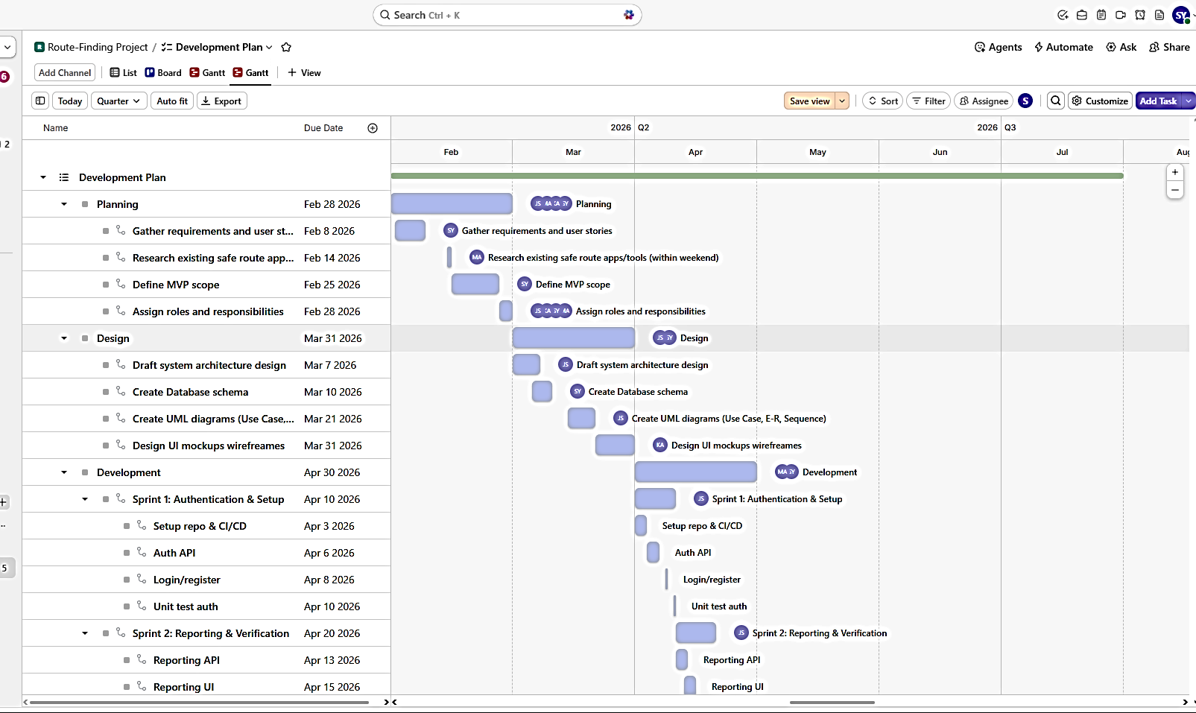

Fig-1: Gant Chart on (ClickUp)

Fig-2: Gant Chart on (ClickUp)

**5. Marketing Plan**

**Objective**

The primary objective of this system is to achieve wide recognition among the users and build trust within broader populations. The platform is designed to engage both categories of stakeholders: individual end users, such as students and daily commuters, and partnered users, including ride-sharing companies, logistics providers, and institutional bodies. Following are the three stages of marketing plan with description:

**Short-Term Marketing Plan**

Focus: In the initial stage the goal is to make people aware of the app, it can be done in several ways:

* **Campus & Community Pilots**: Introduce the system in universities and residential communities where safety is a major/visible concern.
* **Social Media Campaigns**: Use Facebook, Instagram, and WhatsApp groups to share safety tips and highlight app features which consequently acts as awareness campaign.
* **Referral Incentives**: Early users get rewards for reporting incidents and inviting friends.
* **Partnership with Local NGOs/Clubs**: Collaborate with student groups, women’s safety groups, and road safety clubs to spread the word.
* **Press Release/Local Media**: Highlight SafeRoute as a student-led innovation tackling real problems.

**Long-Term Marketing Plan**

 After the initial awareness campaign, the long-term strategy will emphasize scaling the system and establishing strong partnerships. Several measures will support this goal:

* **Partnerships with ride-share and delivery services**: Position SafeRoute as a value-added safety feature for drivers and customers.
* **Corporate and institutional subscriptions**: Provide paid packages to organizations such as courier services, hospitals, logistics and other institutions where staff mobility and safety are critical.
* **App store optimization**: Enhance visibility and discoverability on Google Play and the App Store by improving ratings, keywords, and user reviews.
* **Geographical expansion**: Extend the service gradually, beginning in Dhaka and later moving into other major cities in Bangladesh.

**Continuous Marketing Plan**

After awareness and partnership, the next phase is the continuous strategy which will focus on maintaining user engagement and strengthening trust within the community. Several initiatives will support this ongoing effort:

* **Gamification features**: Introduce reward points for verified reports and recognition badges for active contributors.
* **Regular content and updates**: Share safety insights, heat maps and monthly safety reports through social media channels to sustain visibility.
* **Feedback mechanisms**: Use in-app surveys and direct user feedback to guide improvements and address concerns quickly.
* **Trust and verification campaigns**: Emphasize the role of verification and anti-spam measures to build confidence in the accuracy of reports.
* **Community events and workshops**: Organize awareness sessions in schools, universities, and workplaces to expand reach and reinforce credibility.

**Expected Outcomes**

* **Short-term**: Generates initial interest and awareness and encourage adoption among early users.
* **Long-term**: It Positions SafeRoute as a reliable safety-technology platform with paying partners.
* **Continuous**: It preserves trust, ensures ongoing user participation, and creates a self-sustaining reporting ecosystem.

**6. Cost and Profit Analysis**

**Estimations:**

* **Project Duration Target:** 6 months (MVP).
* **Project Type (for model):** Semi-detached.

*Semi-detached was chosen since the project has medium size (~4.5 KLOC), average complexity, and moderate flexibility.”

* **Size (SLOC):** 4,500.
* **COCOMO Coefficients:**

Effort constant **a = 3**,

effort exponent **P = 1.12**,

duration constant **c = 2.50**,

time exponent **T = 0.35**

**Estimation Using COCOMO (Baseline)**

* Effort (PM): PM=a× (SLOC/1000)^P
* Schedule (DM): DM=c×(PM)T
* Average Staffing (ST): Avg. Staffing (ST):

->ST = PM / DM = 16.17 / 6.62 ≈ 2.45 ≈ 3 people

**Interpretation:** A team of 3 more or less can deliver the MVP in ~6–7 months with ~16 PM of effort.

**Staffing Plan:**

Backend Dev 6 PM, Frontend/Mobile Dev 6 PM, QA/Tester 4 PM, PM (part-time) 2 PM → Total = 18 PM

**Expenditure:**

* Monthly Salaries: Developer BDT 40,000, QA/Tester BDT 30,000, PM BDT 50,000
* Overheads (one-time infra/tools)**:** BDT 50,000
* OpEx (post-launch run-rate): BDT 5,000/month (hosting, notifications, light marketing)
* Revenue Tiers: Small partner BDT 2,000/month; Large partner BDT 10,000/month

We adopt **18 PM** in the staffing plan to cover PM/QA buffers and student context.

### **Staffing-Based Effort & Cost (Bottom-Up)**

### **Person-Months (PM):** Backend 6 + Frontend 6 + QA 4 + PM 2 = **18 PM**

**Capital Expenditure (CapEx – one-time build)**

|  |  |  |  |
| --- | --- | --- | --- |
| Role | Effort (PM) | Rate (BDT/Mo) | COST(BDT) |
| Backend Developer | 6 | 40,000 | 240,000 |
| Frontend/Mobile | 6 | 40,000 | 240,000 |
| QA/Tester | 4 | 30,000 | 120,000 |
| Project Manager | 2 | 50,000 | 100,000 |
| **Subtotal (Labor)** | 18PM | - | 700,000 |
| Overheads (infra/tools) | - | - | 50,000 |
| **Total CapEx** | - | - | 750,000 |

#### **Operating Expenditure (OpEx – recurring)**

* BDT 5,000/month → BDT 60,000/year

### **Break-Even Analysis (Year-1)**

Total Year-1 Cost = **CapEx + OpEx = 750,000 + 60,000 = 810,000BDT**

* **All Large partners (10,000/mo):**

Annual per partner = 120,000 → **810,000 / 120,000 ≈ 7** partners

* **All Small partners (2,000/mo):**

Annual per partner = 24,000 → **810,000 / 24,000 ≈ 34** partners

* **Mixed example (4 Large + 12 Small):**

Monthly = (4×10,000 + 12×2,000) = 64,000 → Annual **768,000**

After OpEx (**60,000**) → **708,000** recovered (near break-even). One more large partner push into surplus.

### **ROI (Return on Investment)**

### **Formula**

ROI= (Net Profit/Total Investment) ×100%

Where:

* **Total Investment (Year-1)** = Development cost (750,000) + OpEx (60,000) = **810,000 BDT**
* **OpEx (Year-2 and onward)** = 60,000 BDT

### **Scenario A – 7 Large Partners**

* Revenue = **840,000 BDT**
* Net Profit = 840,000 − 810,000 = **30,000 BDT**

ROI= (30,000/810,000) ×100%≈3.7%

**Scenario B – 34 Small Partners**

* Revenue = **816,000 BDT**
* Net Profit = 816,000 − 810,000 = **6,000 BDT**

ROI= (6,000/810,000) ×100%≈0.74%

**Scenario C – 5 Large + 12 Small Partners**

* Monthly Revenue = (5 × 10,000) + (12 × 2,000) = 50,000 + 24,000 = **74,000**
* Annual Revenue = 74,000 × 12 = **888,000 BDT**
* Net Profit = 888,000 − 810,000 = **78,000 BDT**

ROI= (78,000/810,000) ×100%≈9.6%

*This is the safest scenario as it does not depend on only one partner.

**Year-2 ROI (CapEx already recovered, only OpEx applies)**

* Example: 7 Large Partners
* Revenue = 840,000 BDT
* Net Profit = 840,000 − 60,000 = 780,000 BDT

ROI= (780,000/60,000) ×100%=1,300%

*This figure looks large because CapEx is sunk; industry practice usually reports ROI across multiple years to avoid distortion.

**Conclusion:**

* COCOMO baseline indicates ~16 PM, 6.6 months, ~3 staff; our staffing plan uses 18 PM to reflect QA/PM buffers.
* CapEx: BDT 750,000; OpEx: BDT 60,000/year.
* Break-even is feasible in Year-1 with ~7 Large or ~34 Small partners; mixed tiers reduce risk.
* ROI is modest in Year-1 (CapEx recovery phase) and high from Year-2 onward as recurring revenue exceeds OpEx.

**7. Reference**

• Sommerville, I. (2016). *Software engineering* (10th ed.). Pearson Education.

• Pressman, R. S., & Maxim, B. R. (2020). *Software engineering: A practitioner’s approach* (9th ed.). McGraw-Hill Education.

• Google Maps Platform. (2023). *Navigation and route planning*. Retrieved from <https://developers.google.com/maps>

• SafeCity. (2023). *Crowdsourced reporting of harassment and unsafe spaces*. Retrieved from <https://safecity.in>

• ClickUp.(2023). *Project management for software development*. Retrieved from <https://clickup.com>

• Boehm, B. W. (1981). *Software engineering economics*. Prentice-Hall.

* + American International University, SRE - Power Point Slides.